**20MCA 132**

**OBJECT ORIENTED PROGRAMMING LAB**

**Cycle 1**

**1. Define a class ‘product’ with data members pcode, pname and price. Create 3 objects of the class and find the product having the lowest price.**

**Code:**

public class product {

int pcode;

String pname;

double price;

product(int code, String name,double rate){

pcode=code;

pname=name;

price=rate;

}

void display(){

System.out.println(pcode+"\t\t"+pname+"\t\t"+price);

}

static void lowest(double p1, double p2, double p3){

if(p1<p2&&p1<p3)

{

System.out.println("Product 1 has the lowest price");

}

else if(p2<p1&&p2<p3){

System.out.println("Product 2 has the lowest price");

}

else if(p3<p1&&p2>p3)

{

System.out.println("Product 3 has the lowest price");

}

}

public static void main(String[] args) {

System.out.println("Name: Denzel Sunny");

System.out.println("Addmission_no: 22MCA022");

System.out.println("Course ID & Code : OOP LAB, 20MCA132");

System.out.println("Date: 24/03/2023");

System.out.println("____________________________________\n");

product obj1=new product(1,"Shampoo",400);

product obj2=new product(2,"Glass",20);

product obj3=new product(3,"Book",100);

System.out.println("\nProduct Information\n\nProduct_Code\tProduct_Name\tProduct_Price");

obj1.display();

obj2.display();

obj3.display();

lowest(obj1.price,obj2.price,obj3.price);

}

}

**Output:**

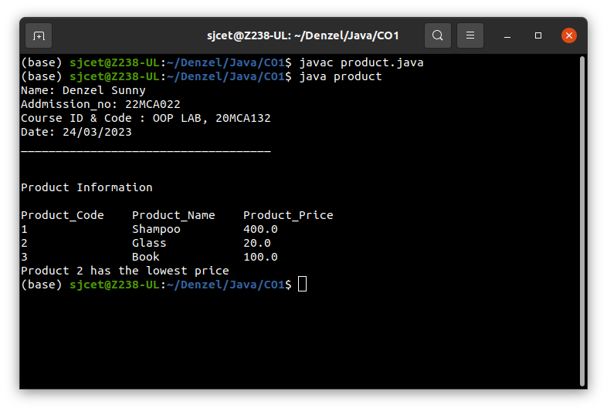

**2. Read 2 matrices from the console and perform matrix addition.**

**Code:**

import java.util.Scanner;

public class matrix

{

public static void main(String args[])

{

System.out.println("Name: Denzel Sunny");

System.out.println("Addmission_no: 22MCA022");

System.out.println("Course ID & Code : OOP LAB, 20MCA132");

System.out.println("Date: 28/03/2023");

System.out.println("____________________________________\n\n");

int p, q, m, n;

Scanner in = new Scanner(System.in);

System.out.println("Enter number of rows in first matrix: ");

p = in.nextInt();

System.out.println("Enter number of columns in first matrix: ");

q = in.nextInt();

System.out.println("Enter number of rows in second matrix: ");

m = in.nextInt();

System.out.println("Enter number of columns in second matrix: ");

n = in.nextInt();

if (p == m && q == n)

{

int a[][] = new int[p][q];

int b[][] = new int[m][n];

int c[][] = new int[m][n];

System.out.println("Enter elements of first matrix: ");

for (int i = 0; i < p; i++)

for (int j = 0; j < q; j++)

a[i][j] = in.nextInt();

System.out.println("Enter elements of second matrix: ");

for (int i = 0; i < m; i++)

for (int j = 0; j < n; j++)

b[i][j] = in.nextInt();

System.out.println("First Matrix: ");

for (int i = 0; i < p; i++)

{

for (int j = 0; j < q; j++)

System.out.print(a[i][j]+" ");

System.out.println(" ");

}

System.out.println("second Matrix: ");

for (int i = 0; i < m; i++)

{

for (int j = 0; j < n; j++)

{

System.out.print(b[i][j]+" ");

}

System.out.println(" ");

}

for(int i=0; i<p; i++)

for(int j=0; j<n; j++)

for(int k=0; k<q; k++)

c[i][j] = a[i][j] + b[i][j];

System.out.println("Matrix after addition: ");

for(int i=0; i<p; i++)

{

for(int j=0; j<n; j++)

System.out.print(c[i][j]+" ");

System.out.println(" ");

}

}

else

{

System.out.println("Addition would not be possible");

}

}

}

**Output:**

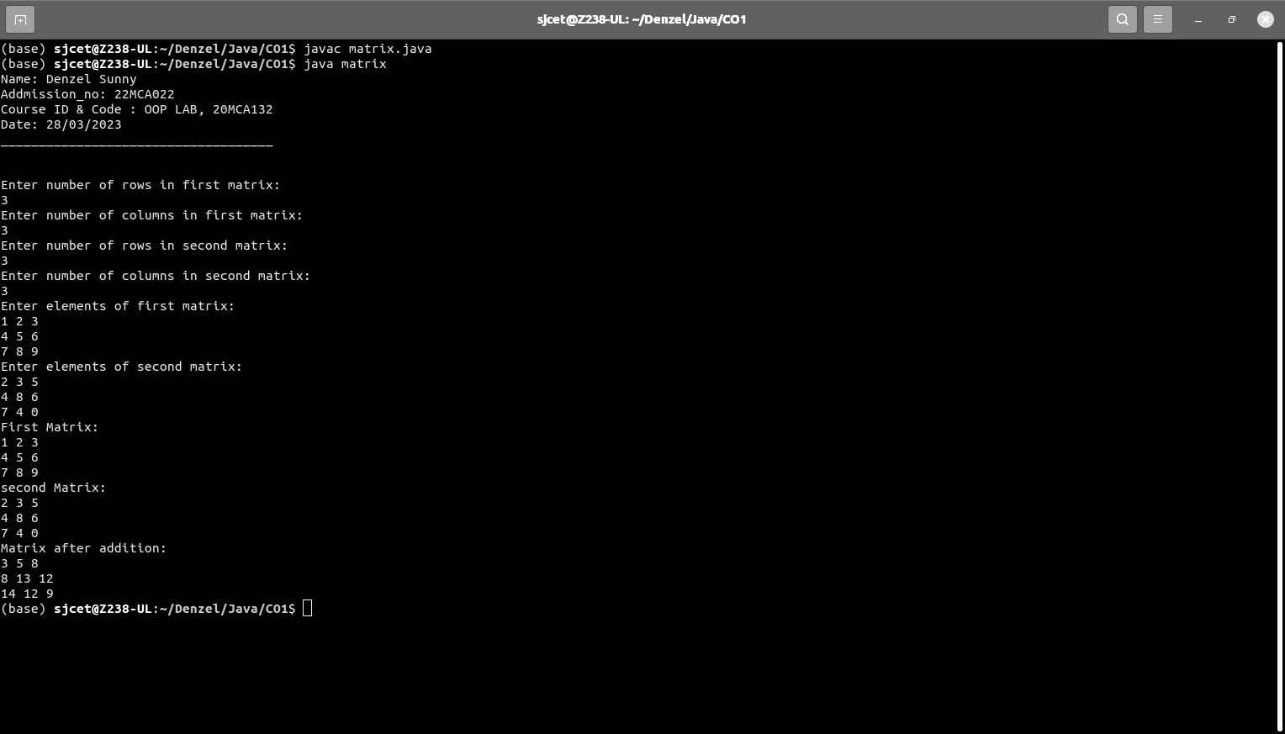

**3. Add complex numbers**

**Code:**

public class complex{

double real, img;

complex(double r, double i){

this.real = r;

this.img = i;

}

public static complex sum(complex c1, complex c2){

complex temp = new complex(0, 0);

temp.real = c1.real + c2.real;

temp.img =c1.img + c2.img;

return temp;

}

public static void main(String args[]){

complex c1 = new complex(5.5, 4);

complex c2 = new complex(1.2, 3.5);

complex temp = sum(c1, c2);

System.out.println("Name: Denzel Sunny");

System.out.println("Addmission_no: 22MCA022");

System.out.println("Course ID & Code : OOP LAB, 20MCA132");

System.out.println("Date: 24/03/2023");

System.out.println("____________________________________\n\n");

System.out.println("Sum is :" + temp.real+" + "+ temp.img + "i");

}

}

**Output:**

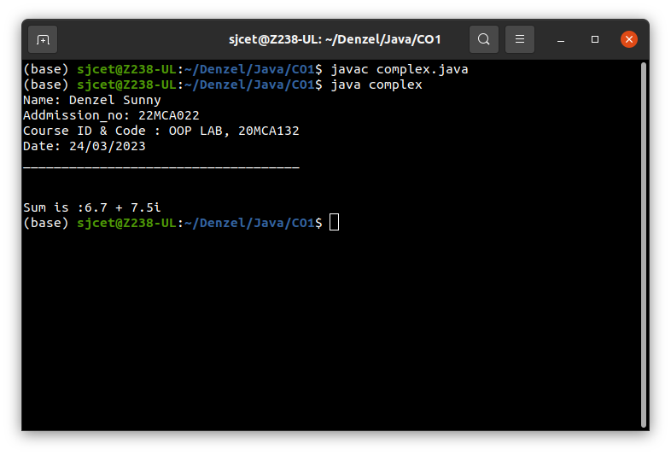

**4. Read a matrix from the console and check whether it is symmetric or not.**

**Code:**

import java.util.Scanner;

class symmetric{

public static void main(String[] args){

System.out.println("Name: Denzel Sunny");

System.out.println("Addmission_no: 22MCA022");

System.out.println("Course ID & Code : OOP LAB, 20MCA132");

System.out.println("Date: 28/03/2023");

System.out.println("____________________________________\n\n");

Scanner sc = new Scanner(System.in);

System.out.println("enter the number of rows : ");

int rows = sc.nextInt();

System.out.println("enter the number of columns : ");

int cols = sc.nextInt();

int matrix[][] = new int[rows][cols];

System.out.println("Enter the elements : ");

for(int i=0; i<rows; i++)

for(int j=0; j<cols; j++)

matrix[i][j] = sc.nextInt();

sc.close();

System.out.println("Printing input matrix : ");

for(int i=0; i<rows; i++)

{

for(int j=0; j<cols; j++)

System.out.print(matrix[i][j]+"\t");

System.out.println();

}

if (rows != cols)

System.out.println("The given matrix is not a square matix");

else

{

boolean symmetric = true;

for(int i=0; i<rows; i++)

for(int j=0; j<cols; j++)

if(matrix[i][j] != matrix[j][i])

{

symmetric = false;

break;

}

if(symmetric)

{

System.out.println("The given matrix is symmetric..");

}

else

{

System.out.println("The given matrix is not symmetric..");

}

}

}

}

**Output:**

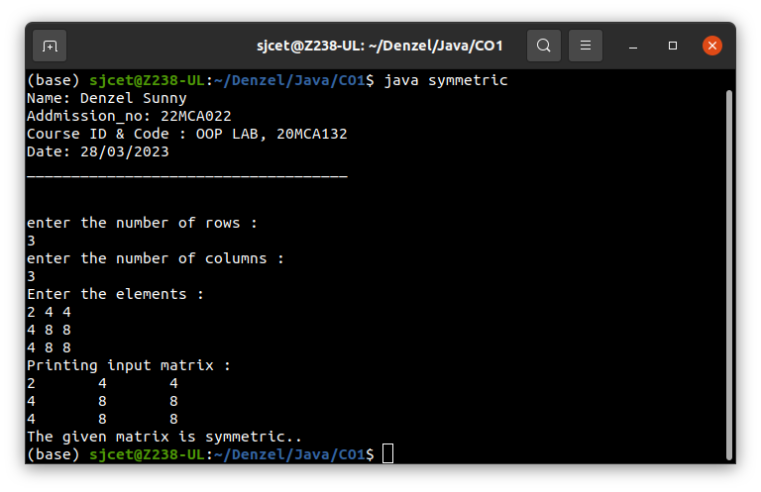

**5. Create CPU with attribute price. Create inner class Processor (no. of cores, manufacturer) and static nested class RAM (memory, manufacturer). Create an object of CPU and print information of Processor and RAM.**

**Code:**

class Cpu {

int price;

Cpu(int p) {

this.price = p;

}

class Processor {

int cores;

String manufacture;

Processor(int n, String m) {

this.cores = n;

this.manufacture = m;

}

void display() {

System.out.println("No of Cores : " + this.cores);

System.out.println("Processor manufactures : " + this.manufacture);

}

}

static class Ram {

int memory;

String manufacture;

Ram(int n, String m) {

this.memory = n;

this.manufacture = m;

}

void display() {

System.out.println("Memory Size : " + this.memory);

System.out.println("Memory manufactures : " + this.manufacture);

}

}

void display() {

System.out.println("Price of CPU : " + this.price);

}

public static void main(String[] args) {

System.out.println("Name: Denzel Sunny");

System.out.println("Addmission_no: 22MCA022");

System.out.println("Course ID & Code : OOP LAB, 20MCA132");

System.out.println("Date: 28/03/2023");

System.out.println("____________________________________\n\n");

Cpu intel = new Cpu(23000);

Cpu.Processor i_processor = intel.new Processor(4, "intel");

Cpu.Ram i_ram = new Ram(1024, "Asus");

intel.display();

i_processor.display();

i_ram.display();

}

}

**Output:**

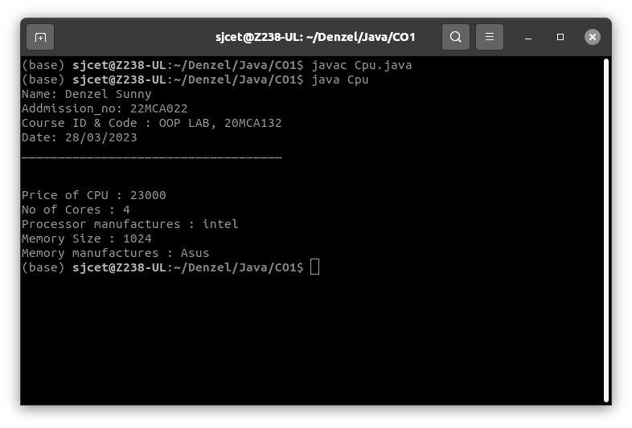

**Cycle 2**

**1. Program to Sort strings**

**Code:**

import java.util.Arrays;

import java.util.Scanner;

public class StringSort {

public static void main(String [] args){

int count = 0;

String tmp;

Scanner scan = new Scanner(System.in);

System.out.println("Enter the number of strings to sort: ");

count = scan.nextInt();

// array to store strings

String str [] = new String[count];

Scanner scan1 = new Scanner(System.in);

System.out.println("Enter strings: ");

for(int i=0; i<count; i++)

str [i] = scan1.nextLine();

System.out.println("1. inbuilt sort() \n 2. user defined sorting()");

System.out.println("Enter your choice: ");

int choice;

choice = scan.nextInt();

switch (choice){

// inbuilt sort.

case 1: Arrays.sort(str);

System.out.println(Arrays.toString(str));

break;

// user defined sorting.

case 2: for(int i=0; i<count; i++)

for(int j=1; j<str.length; j++)

//compare each element to remaining elements.

if(str[i].compareTo(str[j])>0)

{

//swap elements.

tmp = str[i];

str[i] = str[j];

str[j] = tmp;

}

//prints sorted in ascending order.

System.out.println(Arrays.toString(str));

break;

}

}

}

**Output:**

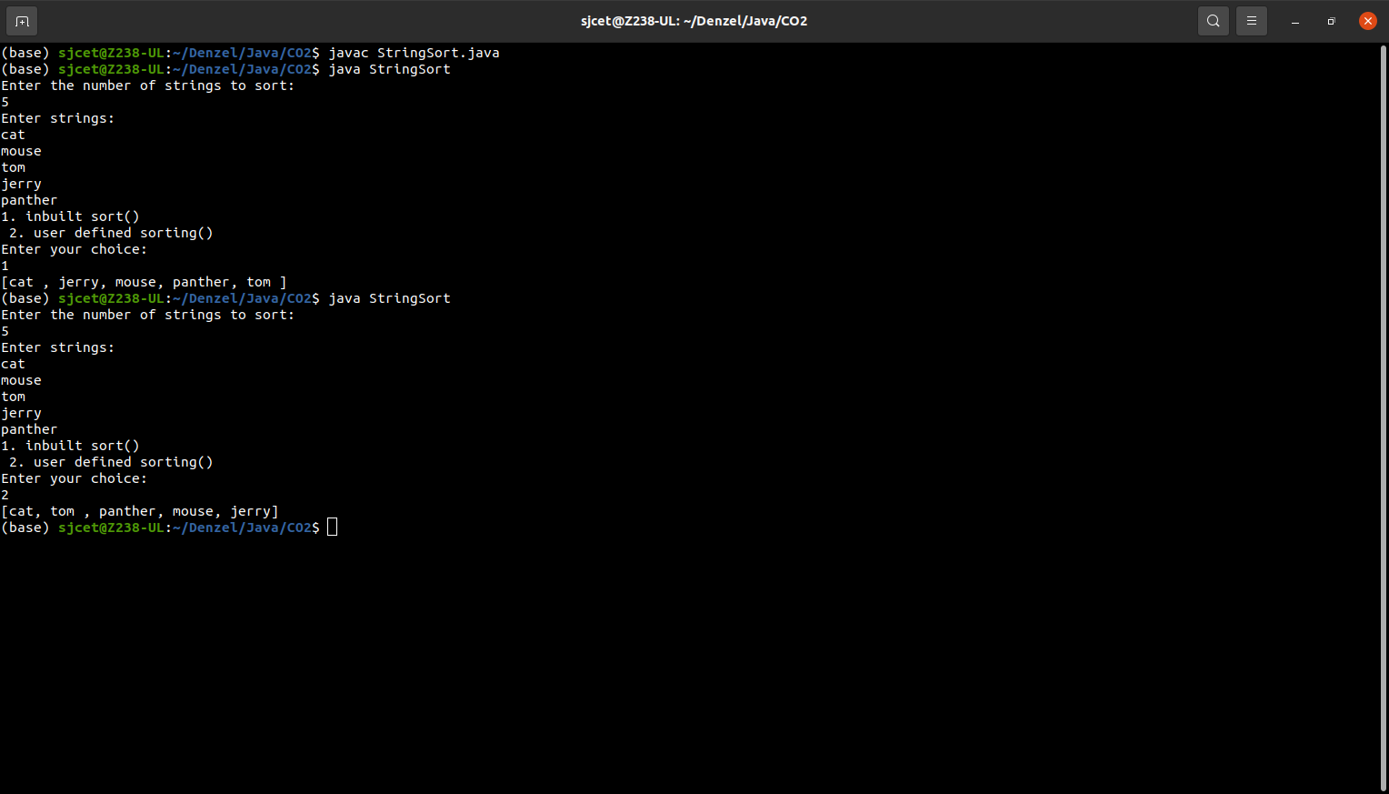

**2. Search an element in an array.**

**Code:**

import java.util.Scanner;

public class Search {

public static void main(String[] args){

int c, n, search, array[];

System.out.println("Name: Denzel Sunny");

System.out.println("Addmission_no: 22MCA022");

System.out.println("Course ID & Code : OOP LAB, 20MCA132");

System.out.println("Date: 12/04/2023");

System.out.println("____________________________________\n\n");

Scanner in = new Scanner(System.in);

System.out.println("Enter the number of elements: ");

n = in.nextInt();

array = new int[n];

System.out.println("Enter those " + n + " elements: ");

for (c = 0; c < n; c++)

array[c] = in.nextInt();

System.out.println("Enter value to find: ");

search = in.nextInt();

for (c=0; c<n; c++)

if(array[c] == search)

{

System.out.println(search + " is present at location " + (c+1));

break;

}

if (c == n)

System.out.println(search + "isn't presesnt in array.");

}

}

**Output:**

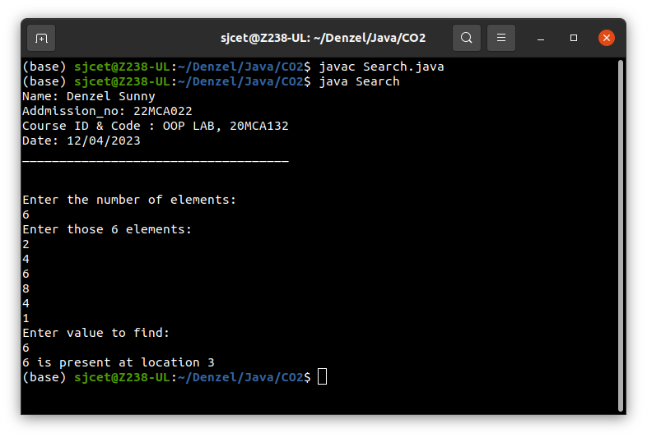

**3. Perform string manipulations**

**Code:**

import java.util.Scanner;

public class string {

public static void main(String[] args) {

System.out.println("Name: Denzel Sunny");

System.out.println("Addmission_no: 22MCA022");

System.out.println("Course ID & Code : OOP LAB, 20MCA132");

System.out.println("Date: 2/05/2023");

System.out.println("____________________________________\n\n");

System.out.println("Enter The String");

Scanner sc = new Scanner(System.in);

String str1 = sc.nextLine();

System.out.println("Length of String = "+str1.length());

System.out.println("Character at First position = "+str1.charAt(0));

System.out.println("String Contains 'Col' sequence :"+str1.contains("Col"));

System.out.println("String ends with e : "+str1.endsWith("e"));

System.out.println("Replace'col' with 'kol' : "+str1.replaceAll("col","kol"));

System.out.println("LOWERCASE : "+str1.toLowerCase());

System.out.println("UPPERCASE : "+str1.toUpperCase());

}

}

**Output:**

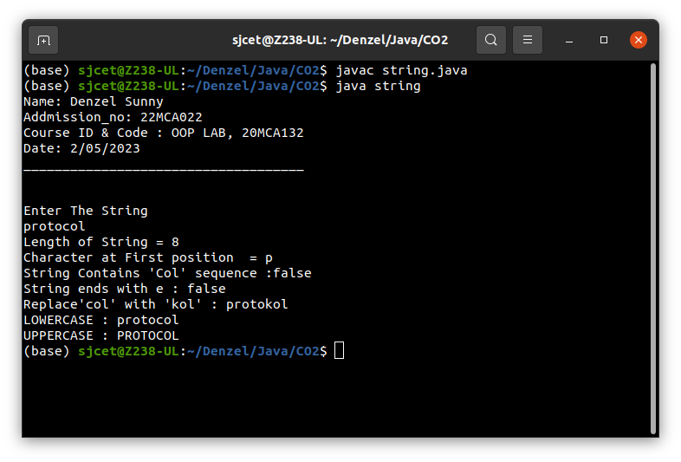

**4. Program to create a class for Employee having attributes eNo, eName eSalary. Read n employ information and Search for an employee given eNo, using the concept of Array of Objects.**

**Code:**

import java.util.Scanner;

public class employee {

int eNo;

String eName;

double eSalary;

public void getdetails(){

Scanner sc = new Scanner(System.in);

System.out.println("\nEnter the Employee details");

System.out.println("Employee number : ");

eNo=sc.nextInt();

System.out.println("Name : ");

sc.nextLine();

eName=sc.nextLine();

System.out.println("Salary : ");

eSalary=sc.nextDouble();

}

void display(){

System.out.println("Empolyee No :"+eNo);

System.out.println("Name :"+eName);

System.out.println("Salary Amount"+eSalary+"\n");

}

public static void main(String[] args) {

System.out.println("Name: Denzel Sunny");

System.out.println("Addmission_no: 22MCA022");

System.out.println("Course ID & Code : OOP LAB, 20MCA132");

System.out.println("Date: 2/05/2023");

System.out.println("____________________________________\n\n");

System.out.println("\nEnter the No. of Employee's");

Scanner sc1 = new Scanner(System.in);

int num = sc1.nextInt();

employee arr[]=new employee[num];

for(int i =0;i<num;i++){

arr[i]=new employee();

arr[i].getdetails();

}

System.out.println("\nInformations of all the employee's");

for(int i=0;i<num;i++){

arr[i].display();

}

boolean state = false;

System.out.println("\nEnter the Employee Number to get details of a employee");

int num2= sc1.nextInt();

for(int i=0;i<num;i++){

if(arr[i].eNo==num2){

System.out.println("\nEmployee details");

arr[i].display();

}

}

}

}

**Output:**

